OOP Assignment 1
Name: Taher Mustansir
Roll: 25K-0119
Section: BAI-2C

Login:
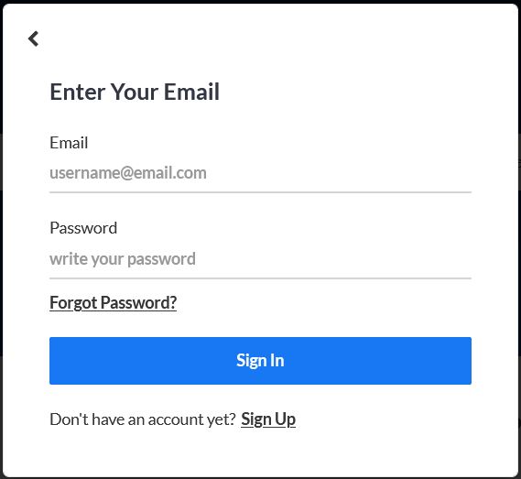

Code:
### Menu Prompt — `src/Menu.h`

```cpp
void handleLogin() {
char username[100], password[100];

std::cout << "\n=== LOGIN ===\n";
std::cout << "Username: ";
std::cin.getline(username, 100);
std::cout << "Password: ";
std::cin.getline(password, 100);

currentUser = app->loginUser(username, password);

if (currentUser) {
std::cout << "Logged in as: " << currentUser->getRole() << "\n";
}
}
```

### Authentication Logic — `src/App.h`

```cpp
User* loginUser(const char* username, const char* password) const {
User* user = findUserByUsername(username);
if (user && user->authenticate(password)) {
std::cout << "Login successful! Welcome, " << username << "\n";
return user;
}
std::cout << "Invalid username or password!\n";
return nullptr;
}
```

### User Lookup — `src/App.h`

```cpp
User* findUserByUsername(const char* username) const {
if (!username) return nullptr;

for (int i = 0; i < userCount; i++) {
if (users[i] && strcmp(users[i]->getUsername(), username) == 0) {
return users[i];
}
}
return nullptr;
}
```

### Password Verification — `src/User.h`

```cpp
bool authenticate(const char* pass) const {
if (!password || !pass) return false;
return strcmp(password, pass) == 0;
}
```

### Reasoning

The login feature follows a layered architecture. The `Menu` class handles user input (UI layer), while `App` acts as the service layer that locates the user and delegates credential verification to the `User` class itself. `findUserByUsername` performs a linear search through the polymorphic `User**` array, and `authenticate` uses `strcmp` for password comparison. The `loginUser` method is marked `const` because it does not modify the application state — it merely returns a pointer to an existing user. By keeping authentication as a member of `User`, each subclass (Admin, Seller, Buyer) inherits the same credential check without duplication, adhering to the DRY principle.

View Listings:

Code:
### Menu Trigger — `src/Menu.h`

```cpp
// Inside showBuyerMenu()
if (choice == 1) {
app->getMarketplace().displayAllListings();
pause();
}
```

### Display All Approved Listings — `src/Marketplace.h`

```cpp
void displayAllListings() const {
std::cout << "\n=== All Approved Listings ===\n";
int approvedCount = 0;
for (int i = 0; i < listingCount; i++) {
if (listings[i] && listings[i]->getIsApproved()) {
listings[i]->display();
approvedCount++;
}
}
if (approvedCount == 0) {
std::cout << "No approved listings available.\n";
} else {
std::cout << "Total approved listings: " << approvedCount << "\n";
}
}
```

### Individual Listing Display — `src/Listing.h`

```cpp
void display() const {
std::cout << "\n========== LISTING #" << listingId << " ==========\n";
std::cout << "Title: " << (title ? title : "N/A") << "\n";
std::cout << "Description: " << (description ? description : "N/A") << "\n";
std::cout << "Status: " << (isApproved ? "APPROVED" : "PENDING") << "\n";
std::cout << "Posted: " << (datePosted ? datePosted : "N/A") << "\n";
if (seller) {
std::cout << "Seller: " << seller->getUsername()
<< " (Shop: " << seller->getShopName() << ")\n";
}
car.display();
std::cout << "========================================\n";
}
```

### Reasoning

The view listings feature only displays **approved** listings to buyers, implementing a basic content moderation workflow. The `Marketplace` iterates over its dynamic `Listing**` array, checking both for null pointers (safety) and approval status (business logic). Each `Listing` delegates car detail rendering to `Car::display()`, which in turn calls `Engine::display()` and `Insurance::display()` — demonstrating composition where the owning object is responsible for displaying its composed parts. The method is `const`-qualified since viewing does not mutate any state, enforcing read-only semantics at the compiler level.

Filter by brand:
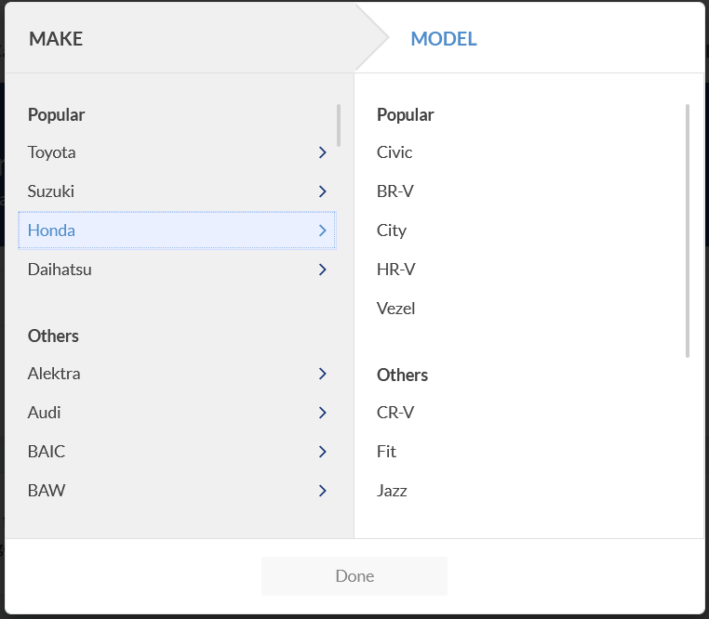

Code:
### Menu Trigger — `src/Menu.h`

```cpp
// Inside showBuyerMenu()
} else if (choice == 2) {
char brand[50];
std::cout << "Enter Brand: ";
std::cin.getline(brand, 50);
app->getMarketplace().searchByBrand(brand);
pause();
}
```

### Search Logic — `src/Marketplace.h`

```cpp
void searchByBrand(const char* brand) const {
if (!brand) return;

std::cout << "\n=== Search Results for Brand: " << brand << " ===\n";
int found = 0;
for (int i = 0; i < listingCount; i++) {
if (listings[i] && listings[i]->getIsApproved()) {
const Car& car = listings[i]->getCar();
if (car.getBrand() && strcmp(car.getBrand(), brand) == 0) {
listings[i]->display();
found++;
}
}
}
if (found == 0) {
std::cout << "No listings found for brand: " << brand << "\n";
} else {
std::cout << "Found " << found << " listing(s).\n";
}
}
```

### Reasoning

The brand filter performs a linear scan of all listings, applying two guard conditions: the listing must be non-null and approved. It then accesses the composed `Car` object via `getCar()` (returning a `const` reference to preserve immutability) and uses `strcmp` for exact string matching on the brand field. The approach is straightforward given the constraint of no STL containers — without `std::map` or hash-based lookups, a sequential scan with `strcmp` is the most appropriate method. The `found` counter provides user feedback on result count, and the null check on `brand` prevents undefined behavior.

Filter by price range:
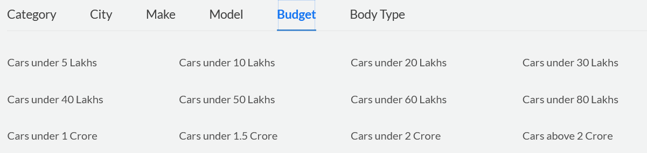

Code:
### Menu Trigger — `src/Menu.h`

```cpp
// Inside showBuyerMenu()
} else if (choice == 3) {
float minPrice, maxPrice;
std::cout << "Min Price: ";
std::cin >> minPrice;
std::cout << "Max Price: ";
std::cin >> maxPrice;
clearInputBuffer();
app->getMarketplace().searchByPriceRange(minPrice, maxPrice);
pause();
}
```

### Search Logic — `src/Marketplace.h`

```cpp
void searchByPriceRange(float minPrice, float maxPrice) const {
std::cout << "\n=== Listings in Price Range: $" << minPrice
<< " - $" << maxPrice << " ===\n";
int found = 0;
for (int i = 0; i < listingCount; i++) {
if (listings[i] && listings[i]->getIsApproved()) {
const Car& car = listings[i]->getCar();
float price = car.getPrice();
if (price >= minPrice && price <= maxPrice) {
listings[i]->display();
found++;
}
}
}
if (found == 0) {
std::cout << "No listings found in this price range.\n";
} else {
std::cout << "Found " << found << " listing(s).\n";
}
}
```

### Reasoning

The price range filter uses an inclusive boundary check (`>=` and `<=`) to match listings whose car price falls within the specified min–max range. Like the brand filter, it only considers approved listings and is declared `const` to guarantee no side effects. The price is retrieved from the composed `Car` object through its getter, maintaining encapsulation — the `Marketplace` never directly accesses `Car`'s private `price` field. The input buffer is explicitly cleared after reading numeric input with `>>` to prevent leftover newline characters from corrupting subsequent `getline` calls, which is a common pitfall in C++ console I/O.

Send message to seller:
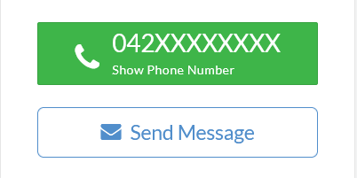

Code:
### Menu Trigger — `src/Menu.h`

```cpp
// Inside showBuyerMenu()
} else if (choice == 8) {
char receiver[100], content[500];
std::cout << "Seller Username: ";
std::cin.getline(receiver, 100);
std::cout << "Message: ";
std::cin.getline(content, 500);
buyer->sendMessage(&app->getMarketplace(), receiver, content);
pause();
}
```

### Buyer Send Message — `src/App.h` (Buyer method implementation)

```cpp
inline void Buyer::sendMessage(Marketplace* marketplace, const char* receiverName,
const char* content) {
if (marketplace && receiverName && content) {
Message* msg = new Message(getUsername(), receiverName, content, "13:30:00");
marketplace->addMessage(msg);
}
}
```

### Marketplace Stores Message — `src/Marketplace.h`

```cpp
void addMessage(Message* message) {
if (!message) {
std::cout << "Cannot add null message!\n";
return;
}

if (messageCount >= messageCapacity) {
resizeMessages();
}

messages[messageCount++] = message;
std::cout << "Message sent successfully!\n";
}
```

### Message Construction — `src/Message.h`

```cpp
Message(const char* sender, const char* receiver, const char* cont,
const char* time)
: messageId(++nextMessageId), isRead(false) {
copyString(senderName, sender);
copyString(receiverName, receiver);
copyString(content, cont);
copyString(timestamp, time);
}
```

### Reasoning

The messaging feature follows a delegation chain: the `Menu` captures input, the `Buyer` creates the `Message` object, and the `Marketplace` stores it. The `Buyer::sendMessage` method is defined in `App.h` (not `Buyer.h`) to resolve the circular dependency — `Buyer` needs `Marketplace`, but `Marketplace` includes `Listing` which includes `Seller`, creating a dependency cycle. By forward-declaring `Marketplace` in `Buyer.h` and placing the implementation in `App.h`, the circular inclusion is broken. The `Message` is heap-allocated with `new` since the `Marketplace` takes ownership and manages its lifetime. The auto-incrementing `nextMessageId` static member ensures unique IDs across all messages.

View Profile: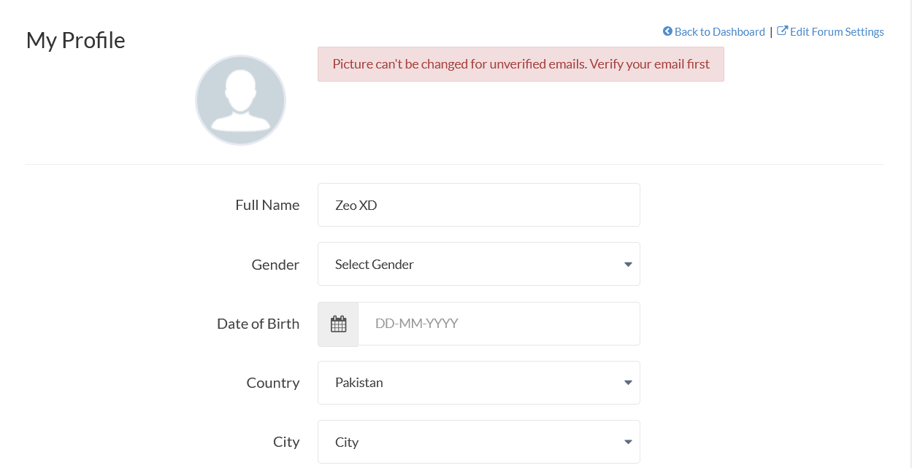

Code:
### Menu Trigger (Buyer) — `src/Menu.h`

```cpp
// Inside showBuyerMenu()
} else if (choice == 9) {
buyer->display();
pause();
}
```

### Menu Trigger (Seller) — `src/Menu.h`

```cpp
// Inside showSellerMenu()
} else if (choice == 5) {
seller->display();
pause();
}
```

### Base User Display — `src/User.h`

```cpp
virtual void display() const {
std::cout << "\n=== User Details ===\n";
std::cout << "User ID: " << userId << "\n";
std::cout << "Username: " << (username ? username : "N/A") << "\n";
std::cout << "Email: " << (email ? email : "N/A") << "\n";
std::cout << "Phone: " << (phone ? phone : "N/A") << "\n";
std::cout << "Status: " << (isActive ? "Active" : "Inactive") << "\n";
std::cout << "====================\n";
}
```

### Buyer Display Override — `src/Buyer.h`

```cpp
void display() const override {
User::display();
std::cout << "Role: Buyer\n";
std::cout << "Budget: $" << budget << "\n";
std::cout << "Preferred Brand: " << (preferredBrand ? preferredBrand : "N/A") << "\n";
std::cout << "Favorites: " << favoriteCount << "/" << maxFavorites << "\n";
}
```

### Seller Display Override — `src/Seller.h`

```cpp
void display() const override {
User::display();
std::cout << "Role: Seller\n";
std::cout << "Shop Name: " << (shopName ? shopName : "N/A") << "\n";
std::cout << "Rating: " << rating << "/5.0\n";
std::cout << "Total Sales: " << totalSales << "\n";
std::cout << "Address: " << (address ? address : "N/A") << "\n";
std::cout << "Seller Since: " << (sellerSince ? sellerSince : "N/A") << "\n";
}
```

### Reasoning

View profile leverages **runtime polymorphism** through virtual function overriding. The base `User::display()` prints common fields (ID, username, email, phone, status), and each derived class (`Buyer`, `Seller`) calls `User::display()` first before appending role-specific details. This follows the Open/Closed Principle — new user types can extend the display behavior without modifying the base class. The `override` keyword ensures the compiler catches signature mismatches. The `const` qualifier guarantees that viewing a profile is a pure read operation. Null checks on string pointers (e.g., `shopName ? shopName : "N/A"`) prevent segmentation faults when optional fields are unset.

Add favourite:
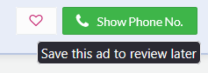

Code:
### Menu Trigger — `src/Menu.h`

```cpp
// Inside showBuyerMenu()
} else if (choice == 5) {
int listingId;
std::cout << "Enter Listing ID to add to favorites: ";
std::cin >> listingId;
clearInputBuffer();
Listing* listing = app->getMarketplace().findListingById(listingId);
buyer->addFavorite(listing);
pause();
}
```

### Listing Lookup — `src/Marketplace.h`

```cpp
Listing* findListingById(int listingId) const {
for (int i = 0; i < listingCount; i++) {
if (listings[i] && listings[i]->getListingId() == listingId) {
return listings[i];
}
}
return nullptr;
}
```

### Add to Favourites — `src/Buyer.h`

```cpp
void addFavorite(Listing* listing) {
if (!listing) {
std::cout << "Invalid listing!\n";
return;
}

if (favoriteCount >= maxFavorites) {
std::cout << "Favorites list is full! Maximum " << maxFavorites << " allowed.\n";
return;
}

// Check if already in favorites
for (int i = 0; i < favoriteCount; i++) {
if (favorites[i] == listing) {
std::cout << "Listing already in favorites!\n";
return;
}
}

favorites[favoriteCount++] = listing;
std::cout << "Listing added to favorites!\n";
}
```

### Reasoning

The favourites feature implements an **aggregation** relationship — the `Buyer` holds pointers to `Listing` objects but does not own them. This is why the `Buyer` destructor deletes the `favorites` array (`delete[] favorites`) but does **not** delete the individual `Listing` objects pointed to within it. The `addFavorite` method enforces three invariants: (1) the listing must be non-null, (2) the favourites list must not exceed its capacity, and (3) duplicates are prevented by comparing pointer addresses. Pointer comparison (`favorites[i] == listing`) is sufficient here because each listing has a unique memory address, so identity comparison is equivalent to equality. The fixed-capacity array with `maxFavorites` avoids the need for dynamic resizing, keeping the implementation simple.

Logout:


Code:
### Buyer Logout — `src/Menu.h`

```cpp
// Inside showBuyerMenu()
} else if (choice == 10) {
currentUser = nullptr;
std::cout << "Logged out successfully!\n";
}
```

### Seller Logout — `src/Menu.h`

```cpp
// Inside showSellerMenu()
} else if (choice == 7) {
currentUser = nullptr;
std::cout << "Logged out successfully!\n";
}
```

### Admin Logout — `src/Menu.h`

```cpp
// Inside showAdminMenu()
} else if (choice == 7) {
currentUser = nullptr;
std::cout << "Logged out successfully!\n";
}
```

### Menu Loop Re-entry — `src/Menu.h`

```cpp
void run() {
showWelcome();

while (isRunning) {
if (!currentUser) {
handleAuth();
} else {
const char* role = currentUser->getRole();
if (strcmp(role, "Admin") == 0) {
showAdminMenu();
} else if (strcmp(role, "Seller") == 0) {
showSellerMenu();
} else if (strcmp(role, "Buyer") == 0) {
showBuyerMenu();
} else {
std::cout << "Unknown role!\n";
currentUser = nullptr;
}
}
}

std::cout << "\nThank you for using " << app->getAppName() << "!\n";
}
```

### Reasoning

Logout is implemented by simply setting `currentUser` to `nullptr`. No memory is freed because the `User` objects are owned by the `App` class (stored in the `users` array) — the `Menu` only holds a non-owning pointer to track the current session. When `currentUser` becomes `nullptr`, the role-specific menu loop (`showBuyerMenu`, `showSellerMenu`, `showAdminMenu`) terminates its `while (isRunning && currentUser)` condition, and the outer `run()` loop detects `!currentUser`, redirecting back to `handleAuth()`. This design cleanly separates session state from object ownership and allows seamless re-login without restarting the application.

View my listings:
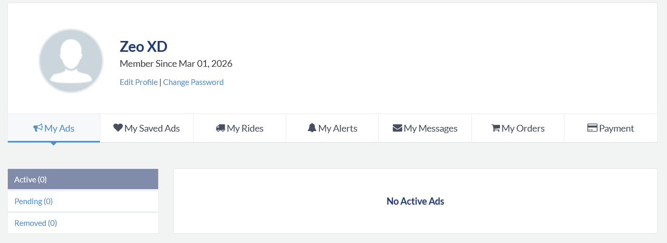

Code:
### Menu Trigger — `src/Menu.h`

```cpp
// Inside showSellerMenu()
if (choice == 1) {
seller->viewMyListings(&app->getMarketplace());
pause();
}
```

### Seller Method — `src/App.h` (Seller method implementation)

```cpp
inline void Seller::viewMyListings(const Marketplace* marketplace) const {
if (marketplace) {
marketplace->getListingsBySeller(getUsername());
}
}
```

### Marketplace Lookup — `src/Marketplace.h`

```cpp
void getListingsBySeller(const char* sellerUsername) const {
if (!sellerUsername) return;

std::cout << "\n=== Listings by " << sellerUsername << " ===\n";
int found = 0;
for (int i = 0; i < listingCount; i++) {
if (listings[i]) {
Seller* seller = listings[i]->getSeller();
if (seller && strcmp(seller->getUsername(), sellerUsername) == 0) {
listings[i]->display();
found++;
}
}
}
if (found == 0) {
std::cout << "No listings found for seller: " << sellerUsername << "\n";
} else {
std::cout << "Total listings: " << found << "\n";
}
}
```

### Reasoning

The "View My Listings" feature uses the seller's username as a filter key. The `Seller` object passes its own username (obtained via the inherited `getUsername()`) to the `Marketplace`, which then iterates through all listings and compares each listing's seller username using `strcmp`. This approach avoids storing a separate per-seller listing index, keeping the data model normalized. The `Seller::viewMyListings` is defined in `App.h` rather than `Seller.h` to resolve the forward-declaration dependency on `Marketplace`. Notably, this displays **all** of the seller's listings regardless of approval status (unlike `displayAllListings`), so the seller can see pending listings awaiting admin review.

Create new listing/ad:


Code:
### Menu Trigger — `src/Menu.h`

```cpp
// Inside showSellerMenu()
} else if (choice == 2) {
handleCreateListing(seller);
pause();
}
```

### Input Gathering — `src/Menu.h`

```cpp
void handleCreateListing(Seller* seller) {
char brand[50], model[50], color[50];
int year, mileage;
float price;
char title[200], description[500];

std::cout << "\n=== CREATE NEW LISTING ===\n";
std::cout << "Car Brand: ";
std::cin.getline(brand, 50);
std::cout << "Car Model: ";
std::cin.getline(model, 50);
std::cout << "Year: ";
std::cin >> year;
std::cout << "Price: ";
std::cin >> price;
std::cout << "Mileage (km): ";
std::cin >> mileage;
clearInputBuffer();
std::cout << "Color: ";
std::cin.getline(color, 50);
std::cout << "Listing Title: ";
std::cin.getline(title, 200);
std::cout << "Description: ";
std::cin.getline(description, 500);

// Create simple engine and insurance
Engine engine("Standard", 150, 2.0f, "Petrol", 4, "Manual");
Insurance insurance(10000 + year, "General Insurance", "Third Party",
2000.0f, "31/12/2027", true);
Car car(brand, model, year, price, mileage, color, engine, insurance);

seller->createListing(&app->getMarketplace(), car, title, description);
}
```

### Seller Creates Listing — `src/App.h` (Seller method implementation)

```cpp
inline void Seller::createListing(Marketplace* marketplace, const Car& car,
const char* title, const char* description) {
if (marketplace) {
Listing* listing = new Listing(car, this, title, description, "13/02/2026");
marketplace->addListing(listing);
}
}
```

### Marketplace Stores Listing — `src/Marketplace.h`

```cpp
void addListing(Listing* listing) {
if (!listing) {
std::cout << "Cannot add null listing!\n";
return;
}

if (listingCount >= listingCapacity) {
resizeListings();
}

listings[listingCount++] = listing;
std::cout << "Listing added to marketplace! Total: " << listingCount << "\n";
}
```

### Reasoning

Creating a listing involves constructing multiple composed objects bottom-up: `Engine` → `Insurance` → `Car` → `Listing`. The `Menu` handles all user input and constructs the `Engine`, `Insurance`, and `Car` objects on the stack. These are then passed by const reference to `Seller::createListing`, which heap-allocates a new `Listing` using `new`. The `Listing` constructor performs a **deep copy** of the `Car` (composition — the listing owns its car), while storing a raw pointer to the `Seller` (aggregation — the listing references but does not own the seller). The `this` pointer is passed so the listing knows its seller. New listings start with `isApproved = false`, requiring admin approval before becoming visible to buyers. The `Marketplace::addListing` method handles dynamic resizing when capacity is reached, doubling the array size to amortize allocation cost.

View my messages:


Code:
### Menu Trigger — `src/Menu.h`

```cpp
// Inside showSellerMenu()
} else if (choice == 6) {
app->getMarketplace().getMessagesForUser(seller->getUsername());
pause();
}
```

### Message Retrieval — `src/Marketplace.h`

```cpp
void getMessagesForUser(const char* username) const {
if (!username) return;

std::cout << "\n=== Messages for " << username << " ===\n";
int found = 0;
for (int i = 0; i < messageCount; i++) {
if (messages[i]) {
const char* receiver = messages[i]->getReceiverName();
if (receiver && strcmp(receiver, username) == 0) {
messages[i]->display();
found++;
}
}
}
if (found == 0) {
std::cout << "No messages for " << username << "\n";
} else {
std::cout << "Total messages: " << found << "\n";
}
}
```

### Message Display — `src/Message.h`

```cpp
void display() const {
std::cout << "\n--- Message #" << messageId << " ---\n";
std::cout << "From: " << (senderName ? senderName : "N/A") << "\n";
std::cout << "To: " << (receiverName ? receiverName : "N/A") << "\n";
std::cout << "Time: " << (timestamp ? timestamp : "N/A") << "\n";
std::cout << "Status: " << (isRead ? "Read" : "Unread") << "\n";
std::cout << "Content: " << (content ? content : "N/A") << "\n";
std::cout << "---------------------------\n";
}
```

### Reasoning

The seller's message view filters the centralized `messages` array in `Marketplace` by matching the receiver name against the seller's username. The `Marketplace` acts as a message broker — all messages are stored in one place rather than being distributed across individual user objects, which simplifies message management and avoids data duplication. The linear scan with `strcmp` comparison is consistent with the project's approach throughout (no STL containers). Each `Message::display()` shows the sender, receiver, timestamp, read status, and content, giving the seller full context about incoming inquiries. The method is `const`-qualified, ensuring that simply viewing messages does not alter the marketplace state.

